truongdeptraivl@gmail.com

July, 2020

PROJECT MEMBERS

**1 ) Nguyễn Tùng Dương - 1611060913   
 2 ) Lê Tiến Trường - 1611060402  
3 ) Lê Phúc Thịnh - 1611060838  
4 ) Lại Nhật Tân - 1611060821**

**FOOD DELIVERY   
APP and WEB**

OUTLINE

**I. OVERVIEW**. 0

**II. ANALYST**. 2

a. Feature comparision table with competitors 2

b. Business canvas model. 3

c. User story list or Usecase diagram with description 4

**III. DESIGN** 4

a. Database design 4

b. Wireframe/prototyp design 7

c. System context model. 10

d. Some flowcharts or state diagram or sequence diagram. 11

**IV.DEMO.** 13

a. Register 13

b. Login/logout 13

c.Homepage 13

d.Search 14

e.Product list 14

f.Product detail 14

g.Add to cart 15

h.Checkout 15

**V. TESTING** 16

**VI. DEPLOYMENT** 16

**VII. TASK LIST** 16

Task list for members 16

I. OVERVIEW.

Retail food delivery is a courier service in which a restaurant, store, or independent food-delivery company delivers food to a customer. An order is typically made either through a restaurant or grocer's website or phone, or through a food ordering company. The delivered items can include entrees, sides, drinks, desserts and are typically delivered in boxes or bags. The delivery person will normally drive a car, but in bigger cities where homes and restaurants are closer together, they may use bikes or motorized scooters.

Customers can, depending on the delivery company, choose to pay online or in person, with cash or card. A flat rate delivery fee is often charged with what the customer has bought. Sometimes no delivery fees is charged depending upon the situation tips are often customary for food delivery service. Contactless delivery may also be an option.  
  
In our system we will let the customer experience the best, fastest and safest delivery system. They can get full control of how their food being deliver, set up a timer on the delivery, how to pay or let other pick up their delivery.

II. ANALYST.

a. Feature comparision table with competitors

A food ordering app is an online intermediary between customers and restaurants, where the diners can order food online from the menus, and have it delivered directly to their addresses.

According to data by market researcher Euromonitor, the online food ordering market in Vietnam is currently projected to top US$38 million by 2020.  
  
The now $33-million market is shared by a number of major players such as Now by Foody Corporation, GrabFood by Grab, and Lala by the on-demand delivery service Ahamove of logistics provider Scommerce.

Developed by Foody – Vietnam's largest social networking site for reviews and shares about dining venues – and officially introduced in 2016, Now, previously known as Delivery Now, has become the leading app in the market.  
  
In July 2017, Foody's founders shared that Now received nearly 10,000 orders per day. The figure may be much bigger at present.

Now has also expanded their services to include grocery, alcoholic beverage, flower, FMCG (fast moving consumer goods), medicine, and laundry deliveries.

Meanwhile, its parent company Foody, initially founded as a website that merely helped users discover restaurants and eateries with its revenue mainly coming from advertisements, has developed an ecosystem that covers a wide range of food-related businesses – ranging from Now to online reservation platform Table Now and restaurant management software Foody POS.

A newcomer that has entered the race but immediately captured the attention of consumers is GrabFood.

GrabFood was tested in Ho Chi Minh City in May and officially launched a month later.

In early October, GrabFood was also officially present in Hanoi after less than a month of piloting.

Grab’s CEO told news website Zing.vn that the number of successful orders GrabFood completed in Ho Chi Minh City in September increased 2.3 times compared to the previous month, while the number of business partners on GrabFood in Hanoi has risen eight times only after one month of testing.

Another player that has been able to leave its mark in the bustling market is Lala.

Lala's CEO revealed that the company already has 6,000 drivers thanks to partnering with Ahamove right from the get-go.

Another notable name includes Vietnammm, which was established in 2011 as a member of Takeaway.com – a Dutch dot-com company specializing in online food ordering and home delivery.

It is not to mention Loship, a platform launched in March and owned by Lozi. The app is associated with CEO Nguyen Hoang Trung, who was named one of the 30 most prominent under-30s in Vietnam by Forbes.

b. Business canvas model.

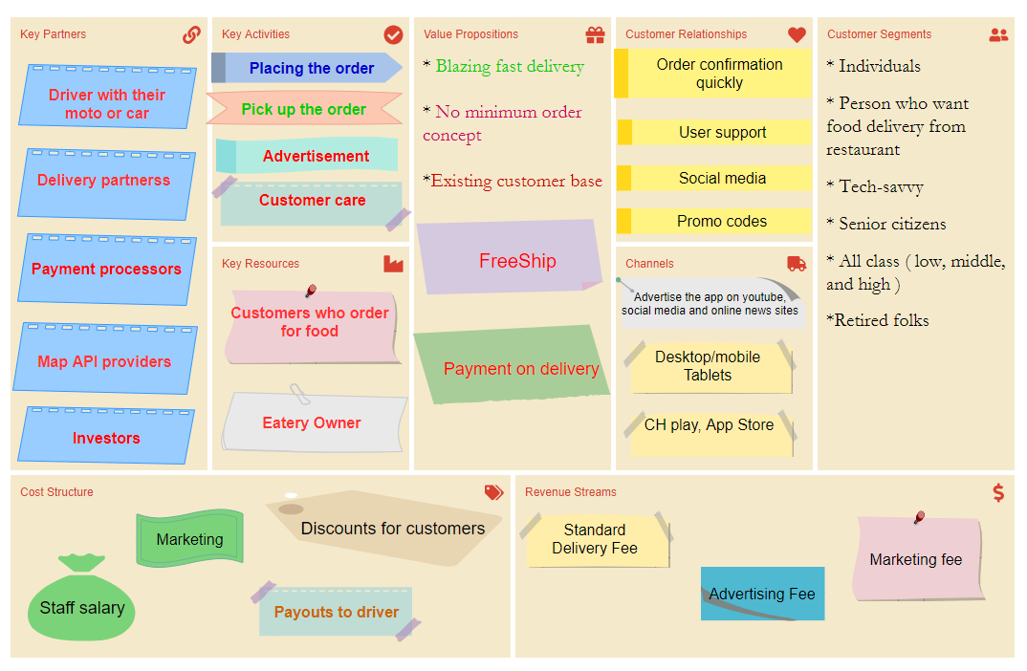

c. User story list or Usecase diagram with description

Landscape and space:

Do customers feel comfortable in a restaurant? How do they rate the restaurant's cleanliness? Do they like the interior design and decor of the house?

Dish

Do customers think your restaurant is worth the money? How satisfied are they with their food choices? How do they judge the quality of the food? , How would you rate the food in a serving?

How satisfied are you with the available food options?

How would you rate the food quality?

Meantime

How long do customers have to wait to order? What is the waiting time for the food?

Staff

Did the staff perform well in the task? Are they friendly? Do they serve customers wholeheartedly?

Why should we receive Food Delivery applications?

The schedule for each application is short, so the delivery time will be fast.

Supporting fee for Uplink Delivery.

Low advance payment.

Small operating range.

Lightweight goods, easy to transport.

III. DESIGN

a. Database design

**Admin >** 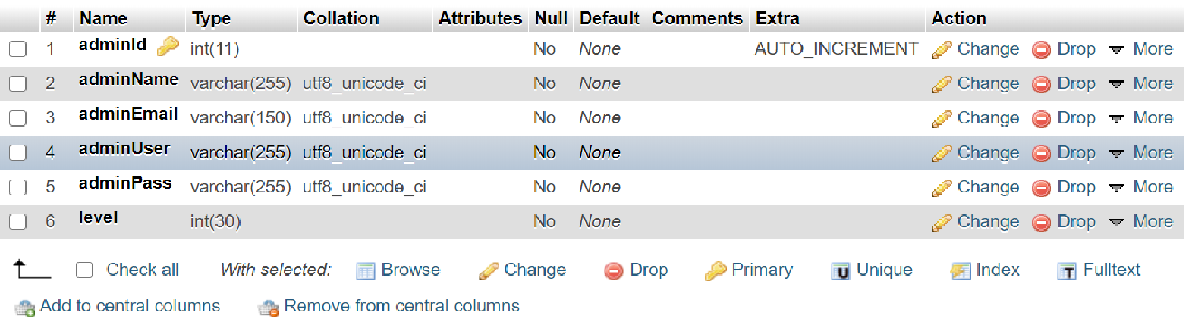

**Brand >**

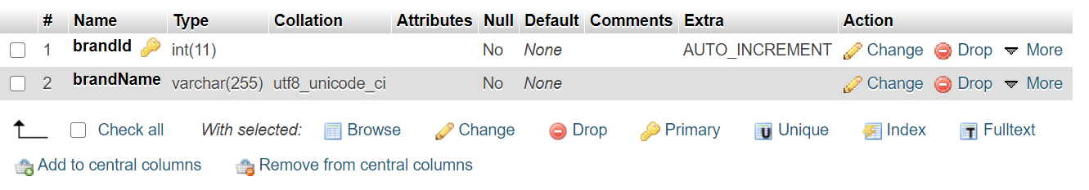

**Category >**

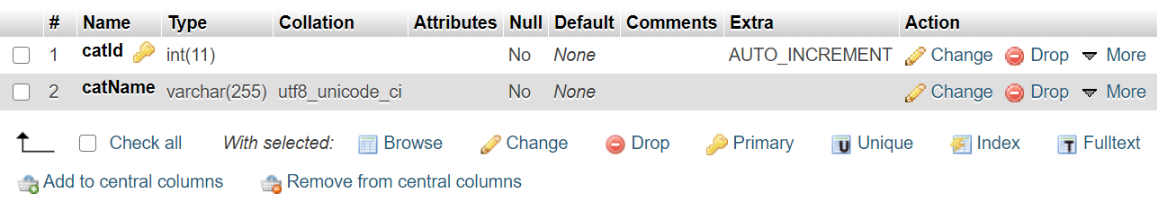

**Cart >**

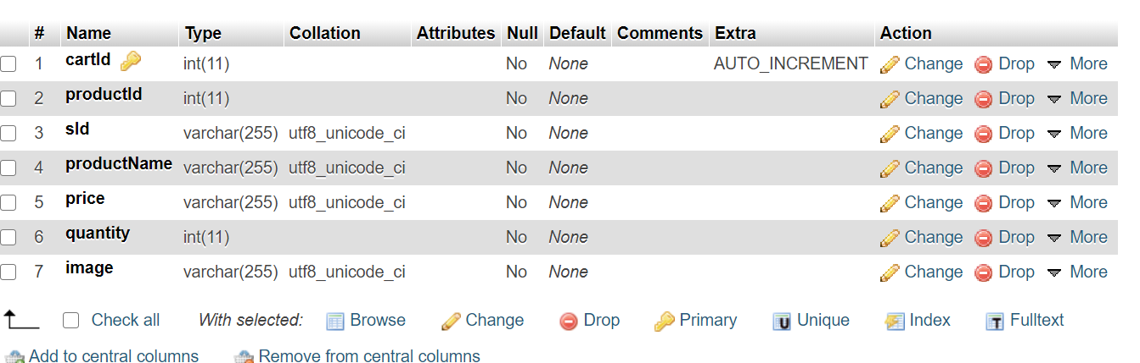

**Customer >**

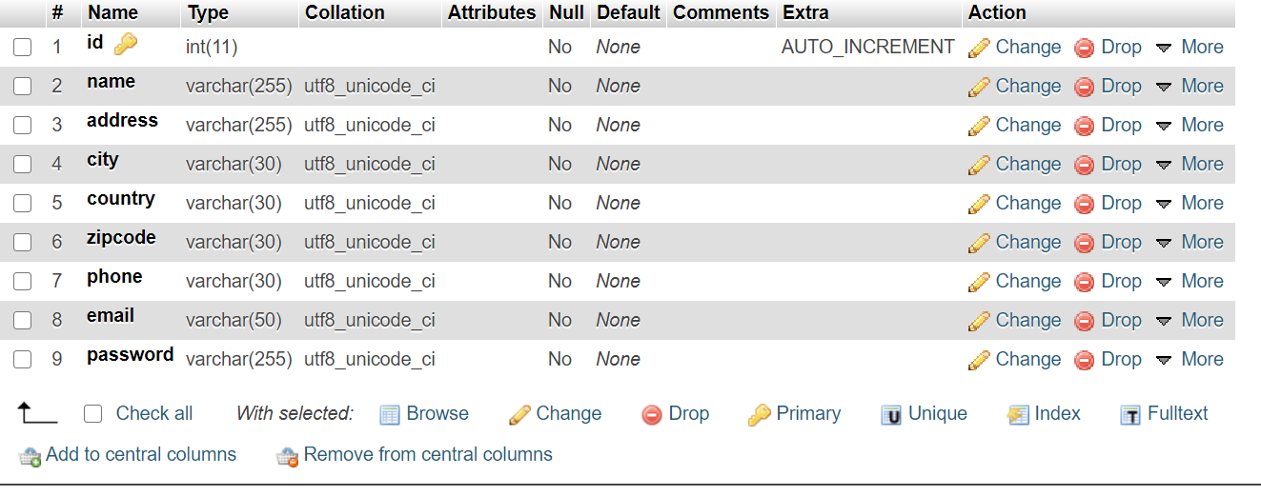

**Order >**

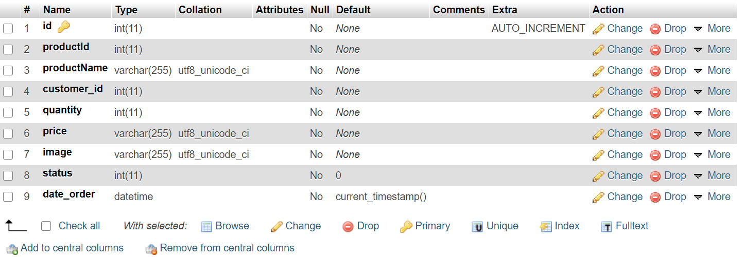

**Warehouse >**

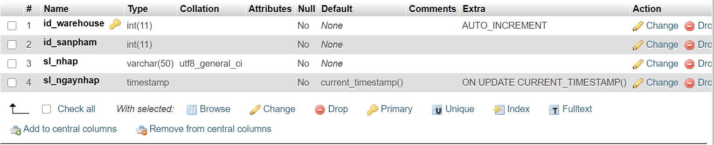

**Customer order >**

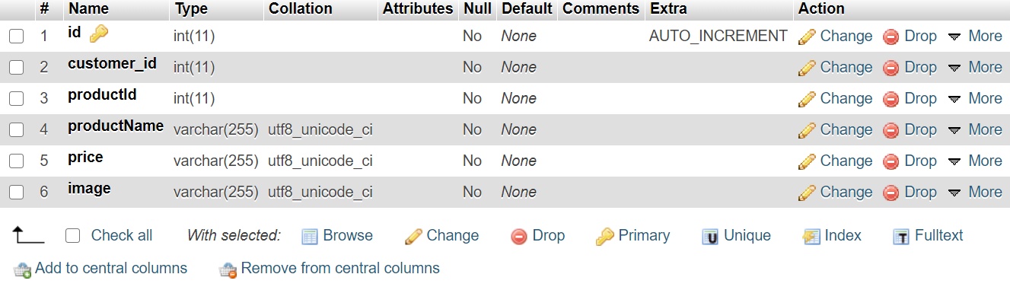

b. Wireframe/prototyp design

**Login >**

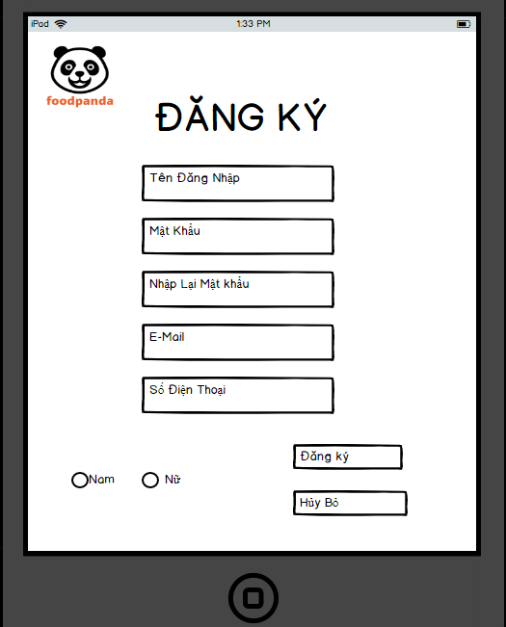 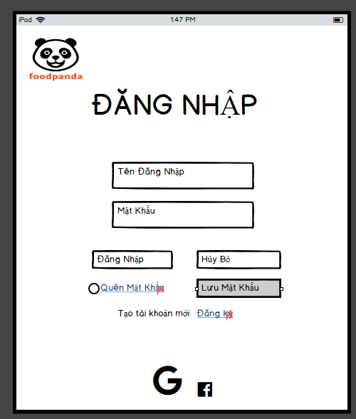

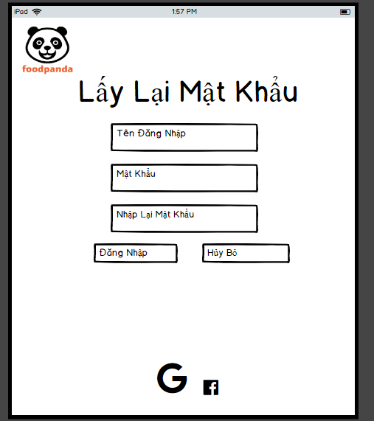

**For WEB )**

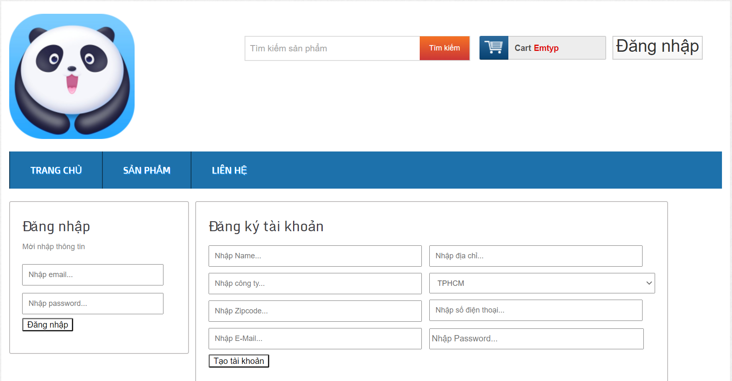

**Food order >**

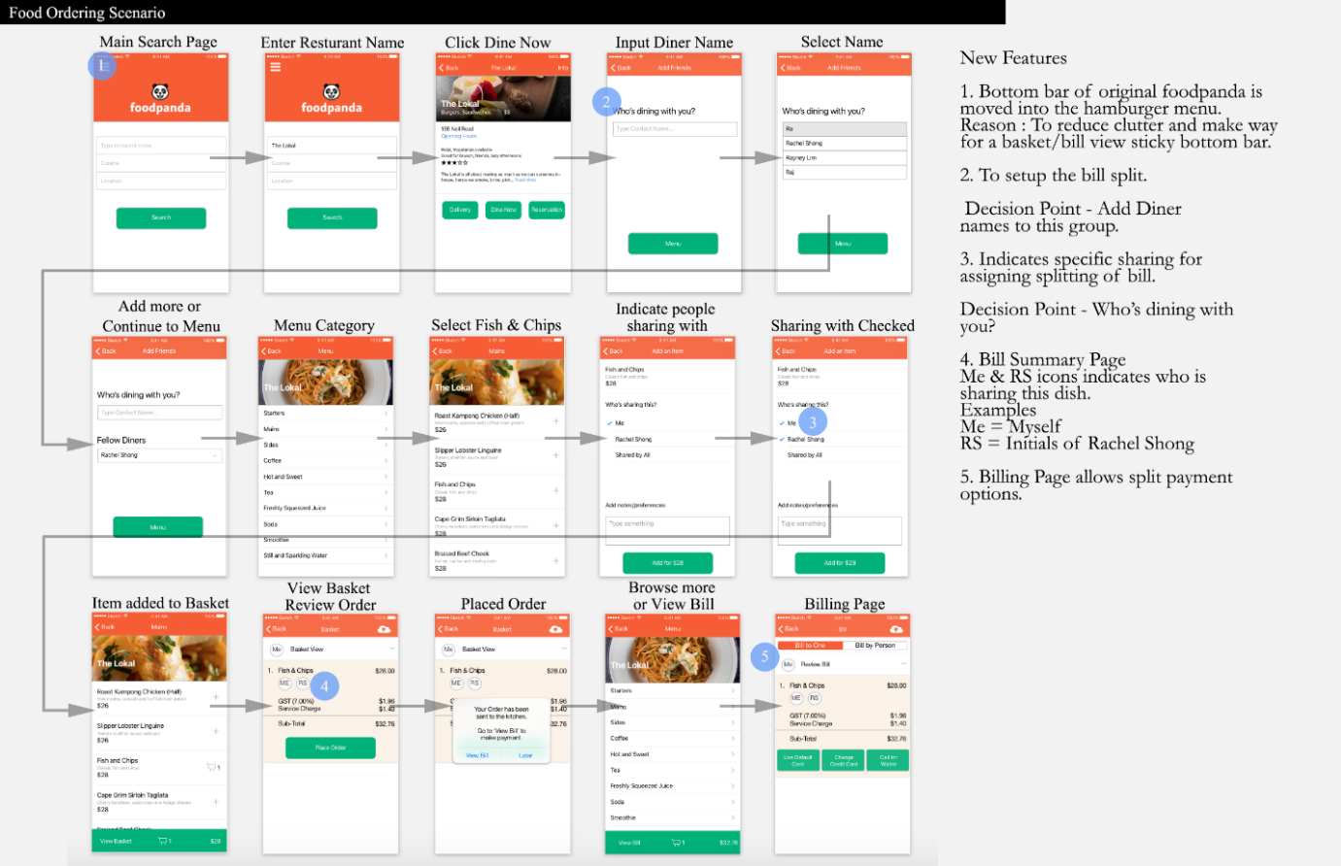

**Payment >**

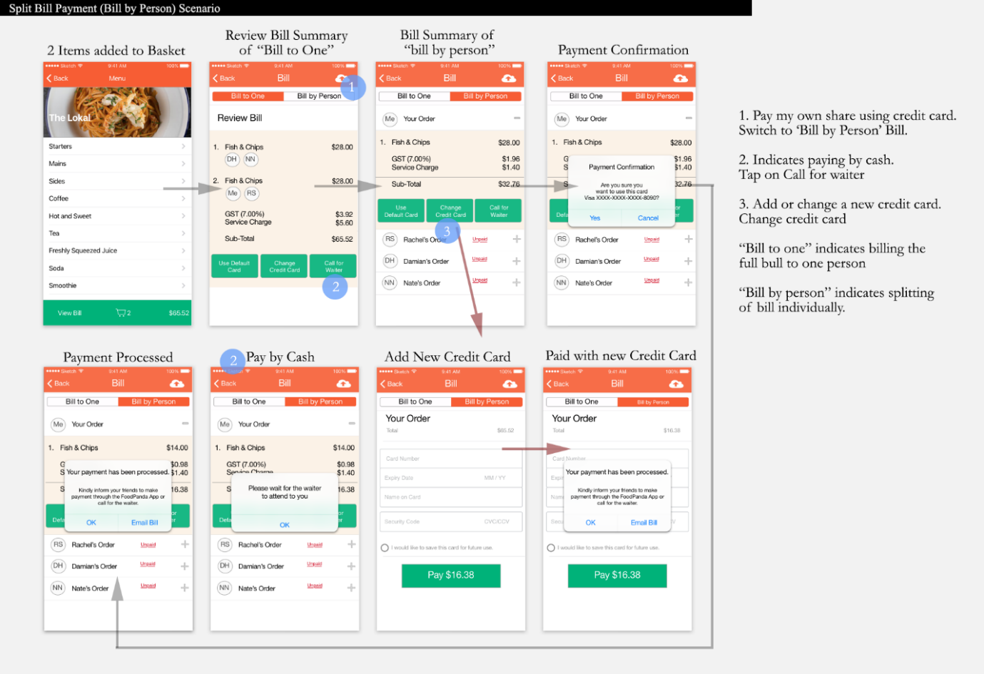

**For web >** 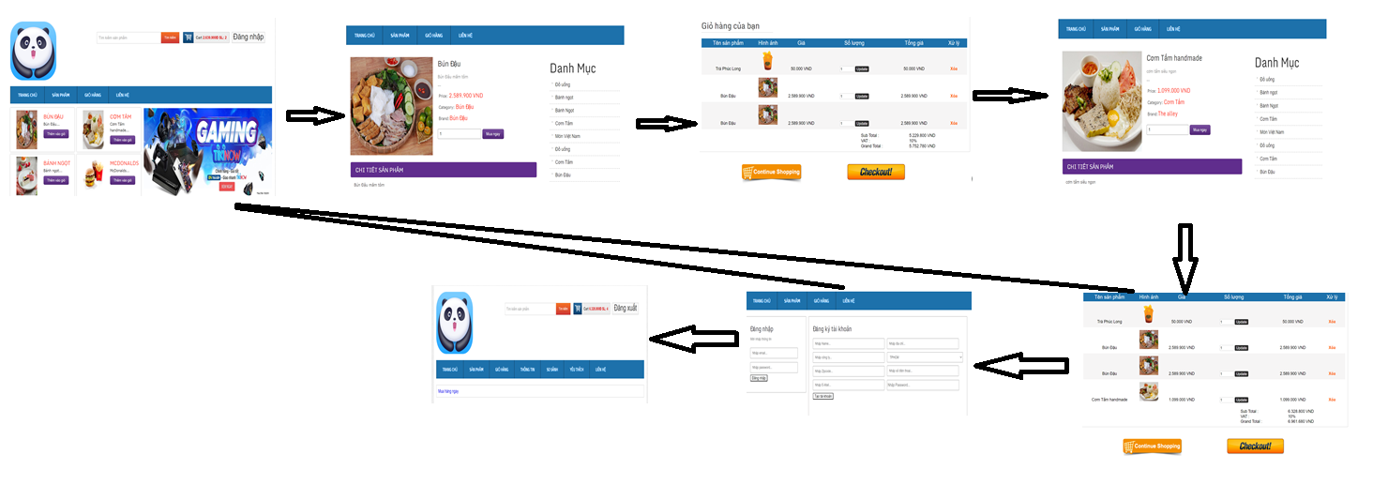

c. System context model.

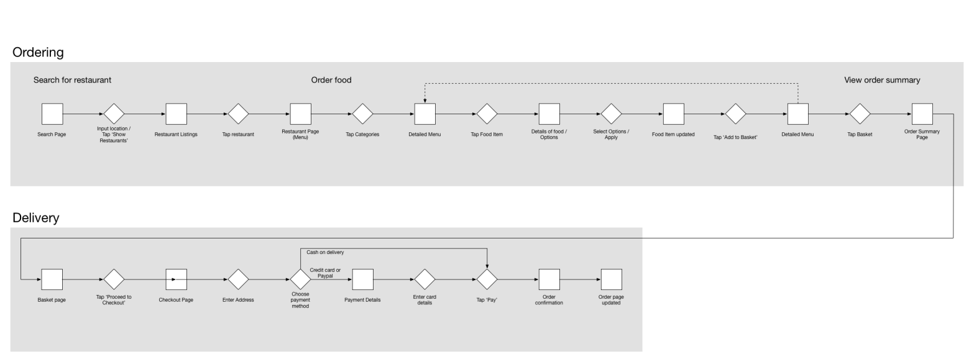

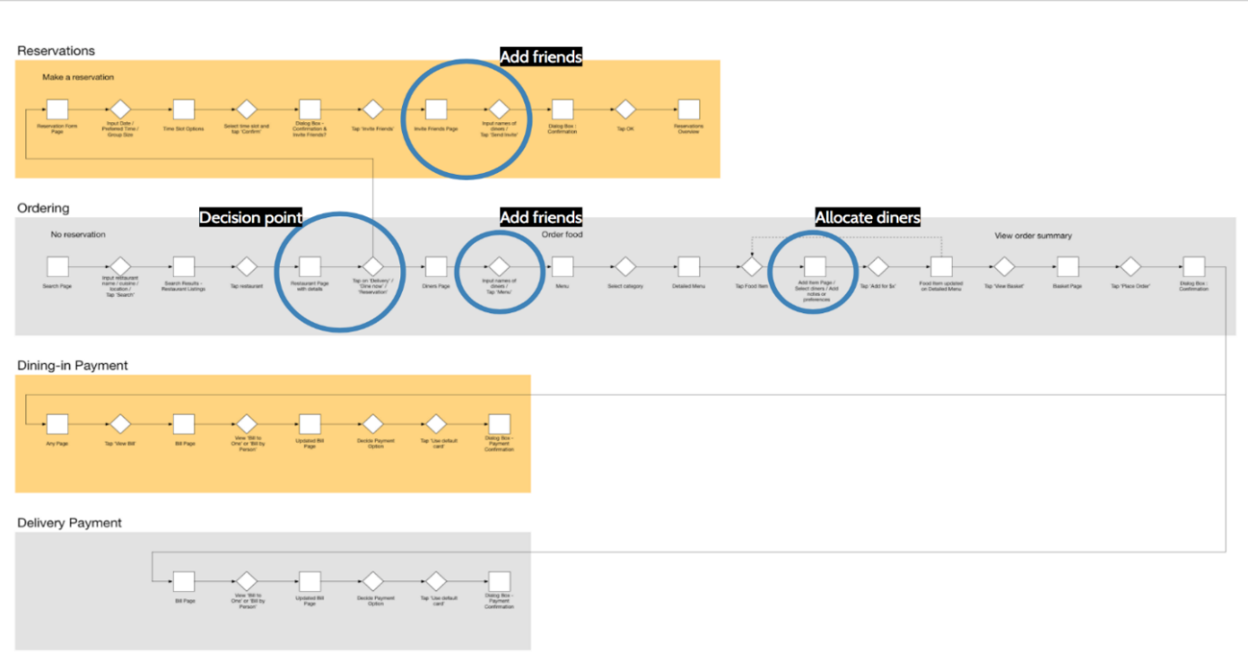

d. Some flowcharts or state diagram or sequence diagram.

**State diagram >.** 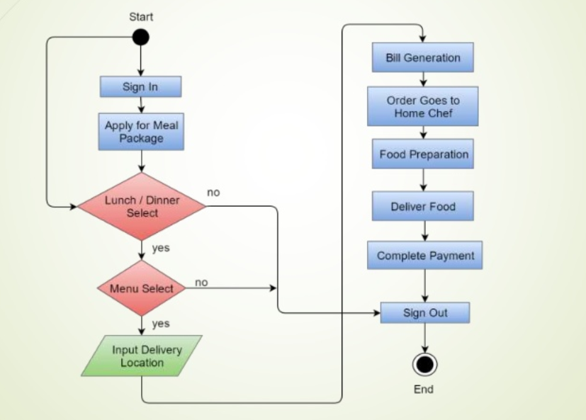 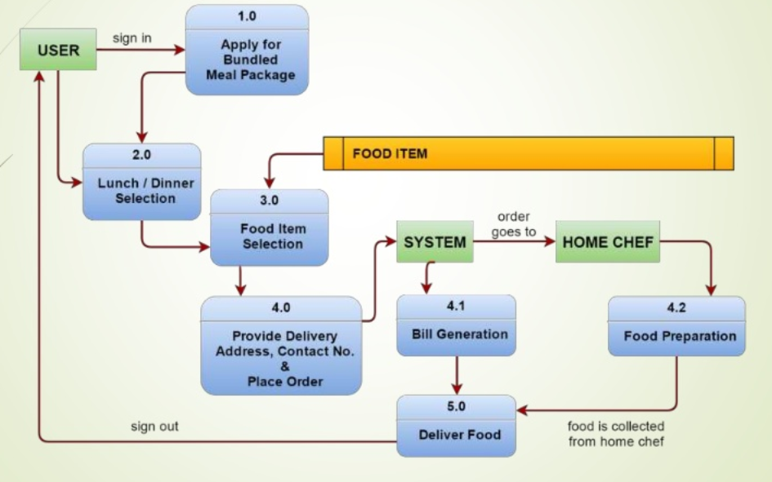

**Sequence diagram >.**

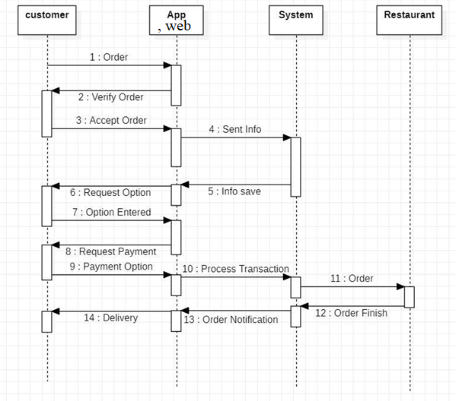

IV.DEMO.

a. Register



b. Login/logout



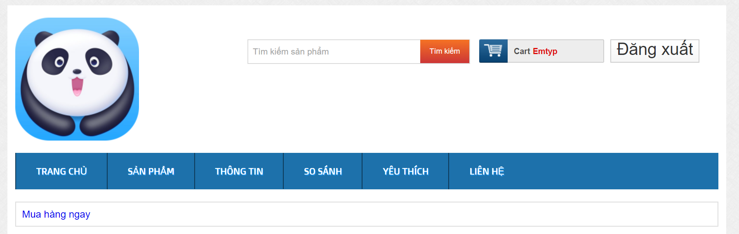

c.Homepage

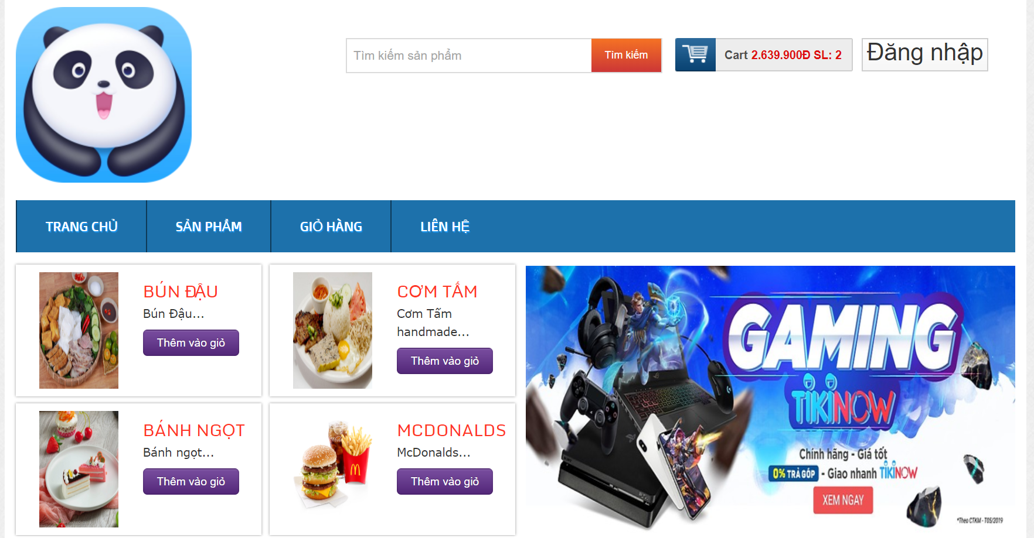

d.Search

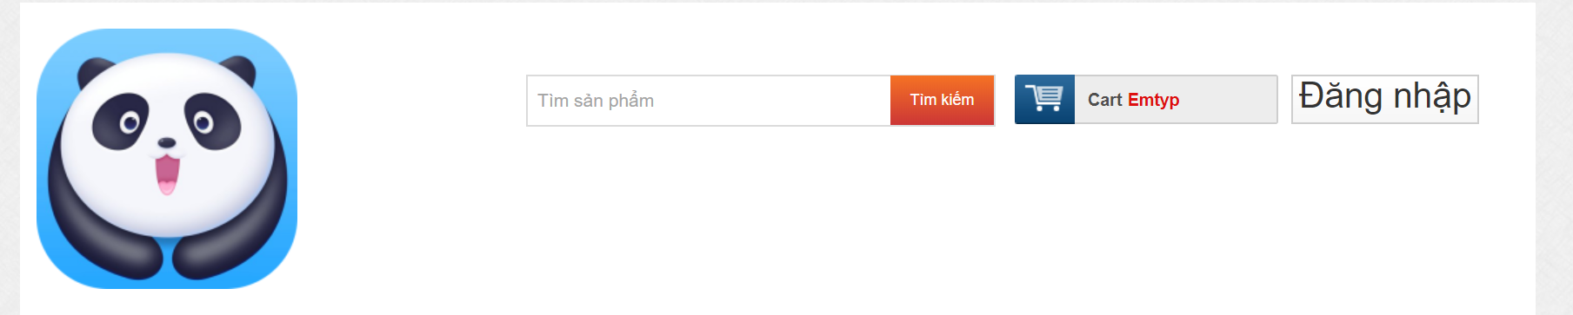

e.Product list

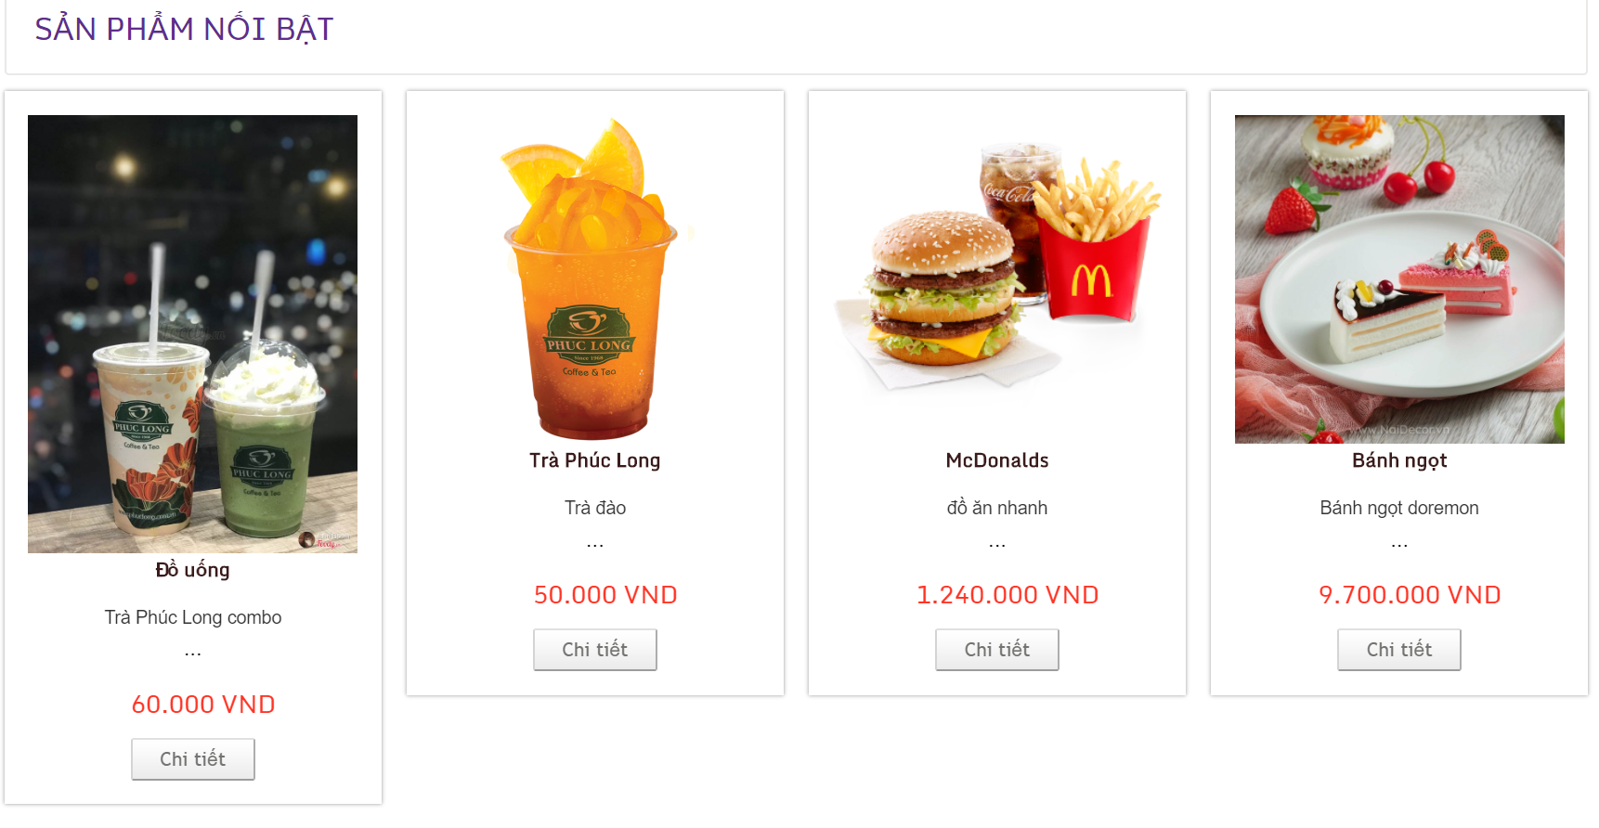

f.Product detail

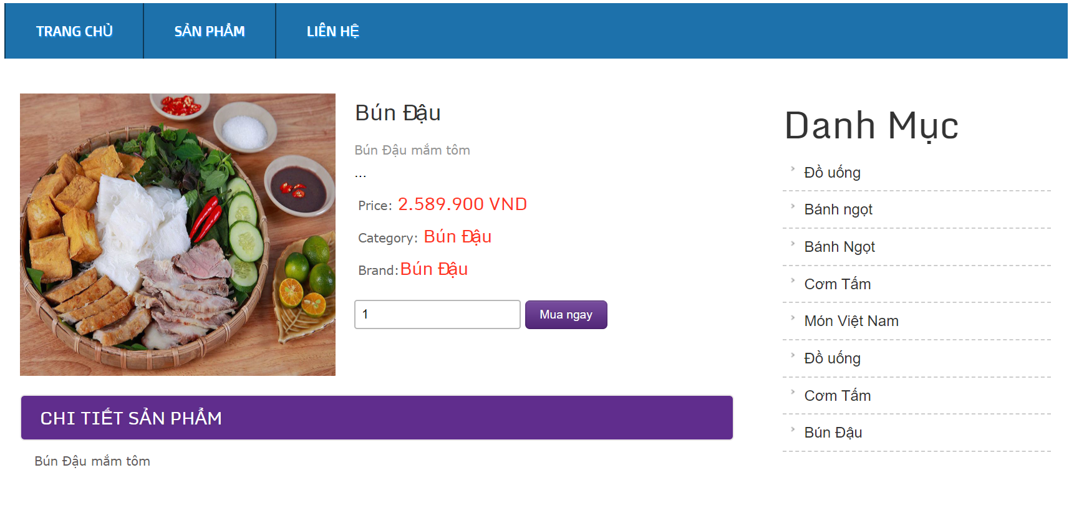

g.Add to cart

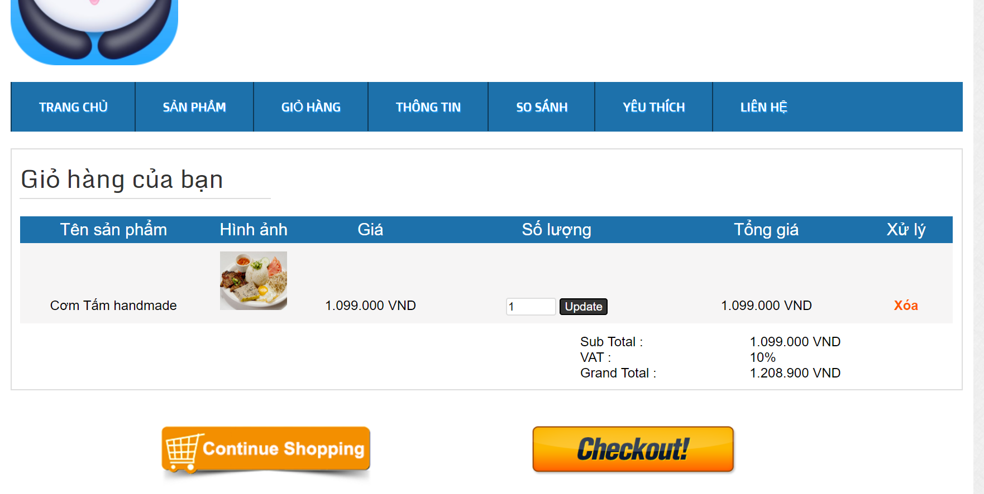

h.Checkout

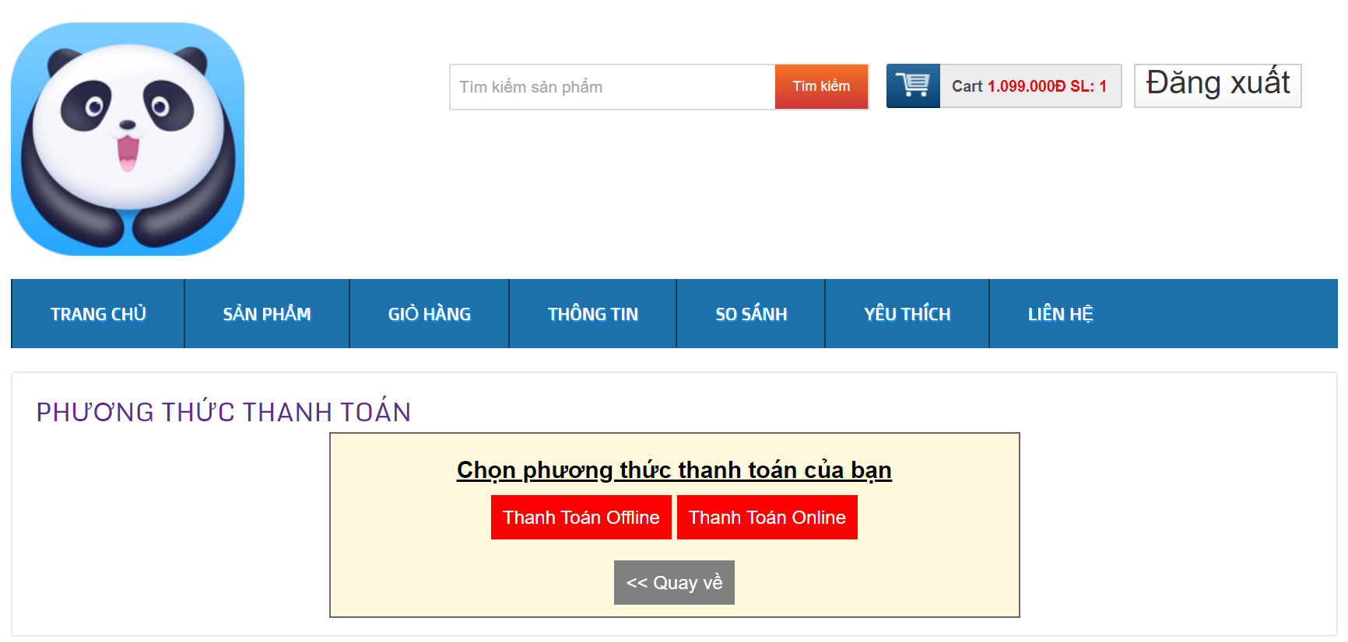

V. TESTING

Lê Tiến Trường - test footer

Lại Nhật Tân - test login

Lê Phúc Thịnh - Test comment

Nguyễn Tùng Dương - Test Cart , Test Search

VI. DEPLOYMENT

VII. TASK LIST

a. Task list for members

**Lê Tiến Trường ( over view )**

a. User story list or Usecase diagram with description , system context

b. database – web

c. test footer

**Lại Nhật Tân ( over view ):**

model canvas

test login

wireframe Login

**Lê Phúc Thịnh ( over view ) :**

Wireframe payment , order APP

Test comment

sequence diagram

**Nguyễn Tùng Dương ( over view ):**

Feature comparision table with competitors , User story list or Usecase diagram with description

b. Test Cart , test search

c. State diagram

No table of contents entries found.